VAR DART 6UL :

GPU, DRM , display, QT

Does the IMX6ul has Vivante GPU or any other GPU?

No

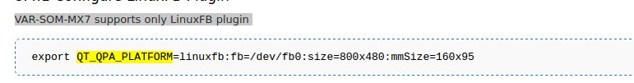

Only for other board
http://www.variscite.com/products/system-on-module-som/cortex-a9/dart-mx6-cpu-freescale-imx6

If so,
we don’t need to enable the driver in kernel ( which is enabled by default in the vart dart linux )

messa driver: - no need – only for vivante 2d and 3d GPU



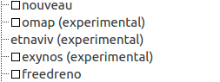

Will be enabled when the mesa drive is enabled.

The var dart 6ul has
2D pixel acceleration engine

What that means?

First , it does not have a GPU chip.
So we don’t need a driver.

http://variwiki.com/index.php?title=Yocto_Build_Release&release=RELEASE_PYRO_V1.0_VAR-SOM-MX7

Touch screen and lcd is working
Only examples that can work with LinuxFB.

We dont need to specify
--platform linuxfb

It should be set by default in case we build the image only with linuxfb

Qt5 – no need for eglfs platforms

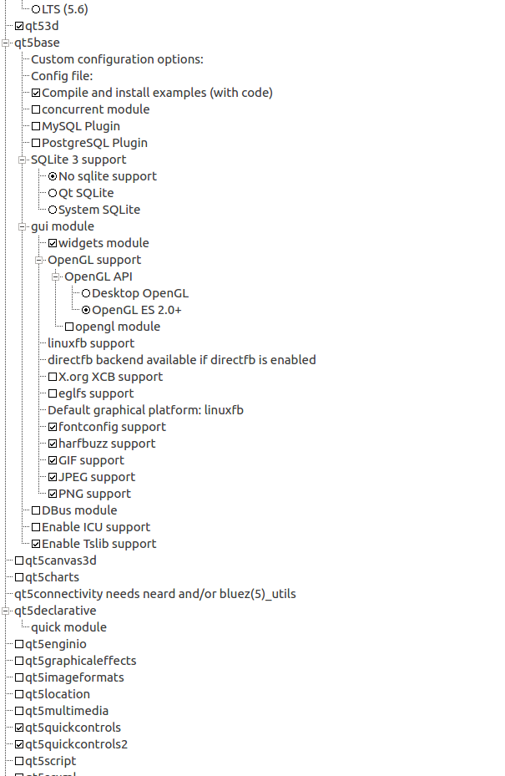

I did not selected eglfs support
and opengl module

only linux fb.

Now I can run it without specify the platform.

